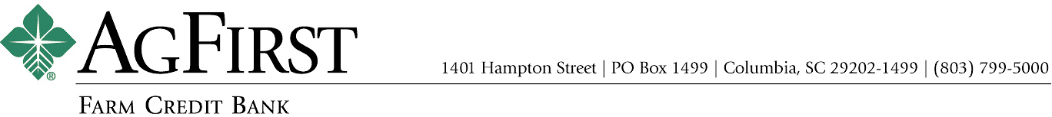

NEWS RELEASE Contacts:
Joy M. Upchurch, Vice President-Marketing
jupchurch@agfirst.com; 803-753-2379
Donna J. Camacho, Director of Communications
dcamacho@agfirst.com; 803-753-2251

for release
Monday, February 24, 2003

AgFirst Executive Named CEO of Texas Bank
Columbia, S.C. —AgFirst Farm Credit Bank announced today that Larry R. Doyle, Executive Vice President and Chief Operating Officer, has been named chief executive officer of the Farm Credit Bank of Texas. Doyle, a 27-year veteran of the Farm Credit System, was most recently responsible for the lending, finance, operations, legal and information management departments of AgFirst. He will assume his new duties on March 17, 2003, in Austin, Texas.
In announcing Doyle’s departure, AgFirst CEO Andy Lowrey said, “Larry’s leadership has been an integral part of the AgFirst’s success, and we are grateful for his contributions. While we will miss Larry, we are excited for him in this great opportunity.” Doyle added, “I’m looking forward to the challenge and opportunity as CEO of the Farm Credit Bank of Texas, but I will be forever grateful for the support of AgFirst which created this opportunity for me.”
Doyle, 50, is a native of Horry County, S.C. He began his career in 1975 as a loan officer for Orangeburg Production Credit Association in Orangeburg, S.C. In 1980, Doyle joined the Columbia Bank for Cooperatives as a business development and credit officer, responsible for agribusiness and utility lending. In 1986, he became vice president and treasurer of the Farm Credit Bank of Columbia, and in 1996, he was named senior vice president for lending and treasury.

AgFirst Executive Named CEO of Texas Bank 2

Doyle will succeed Arnold R. Henson who announced his retirement in December, 2002. The Farm Credit Bank of Texas, headquartered in Austin, is part of the nationwide Farm Credit System. The bank provides funding for 22 rural lending cooperatives in Alabama, Louisiana, Mississippi, New Mexico and Texas. The bank and its affiliated lending cooperatives reported combined total assets of $7.3 billion as of September 30, 2002, which includes $6.6 billion in loans to more than 61,000 farmers, ranchers, agribusinesses and rural homeowners.
AgFirst provides funding and financial services to 24 farmer-owned financial cooperatives, called Agricultural Credit Associations (ACAs) in 15 eastern states and Puerto Rico. These ACAs provide real estate and production financing to more than 80,000 farmers, agribusinesses and rural homeowners. The bank and its affiliated ACAs reported combined total assets of $15.5 billion as of September 30, 2002.
The Farm Credit System is the largest agricultural lending organization in the United States. On a combined basis, the System reported assets of $107 billion on September 30, 2002, as compared to $101 billion on December 31, 2001. The System’s combined net income for the nine months ended September 30, 2002, was $1.37 billion, as compared to $1.29 billion the same period last year.
###

Note: AgFirst CEO Andy Lowrey is available for interviews. To schedule an interview, please call Donna Camacho, Director of Advertising and Communications, at 803-753-2251, or email her at dcamacho@agfirst.com. Additional information is available at www.agfirst.com.

